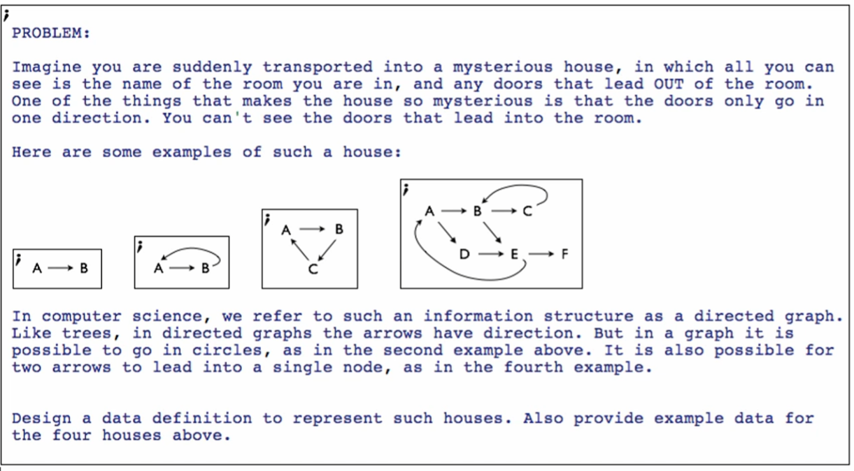

In graphs, a node has

* A name
* Zero or more paths to other nodes

*Data Definition*

**Structure**



**Type comment**



**Interpretation**



**Examples**

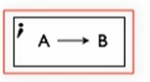



Circular structured graph:

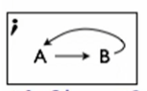



We need the make-room “A” (list … to be also under “B” but we can’t achieve that with just this!

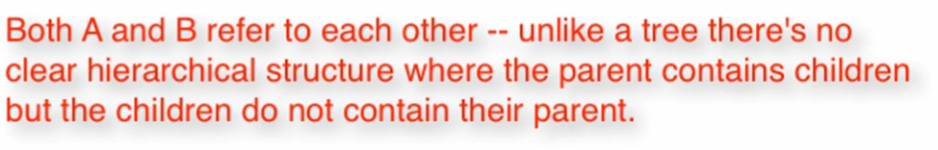

Switch to Advanced Student



shared Primitive

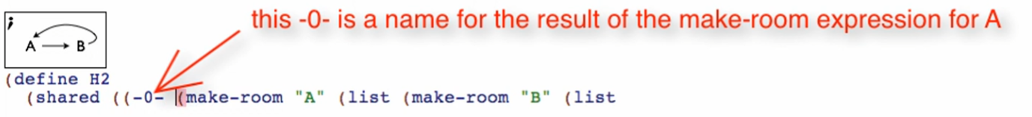

* This name will allow us to refer to this room; even inside the expression that makes this room!



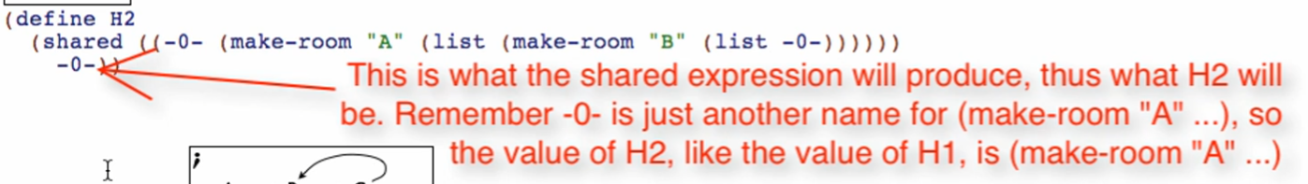

Syntax: (shared ((<shared exp name> (<expression to be shared>)) <return value of shared exp>)))

Now, we do not call the expression like this:



Because it wouldn’t make any sense. It’s a little bit harder to read

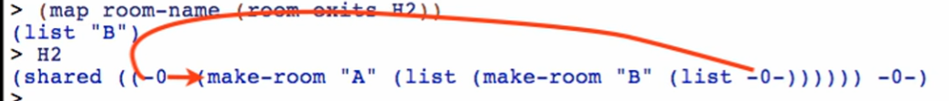

We can use selectors to call it by parts to ensure that our example definition is correct



